**Assignment 9.3**

Create two datasets employee and department of file type text where the columns are delimited by tab ( ‘\t’ ), and use these datasets to perform below Join operations :

● SELF JOIN

● INNER JOIN

● LEFT OUTER JOIN

● RIGHT OUTER JOIN

● FULL OUTER JOIN

**Input:**

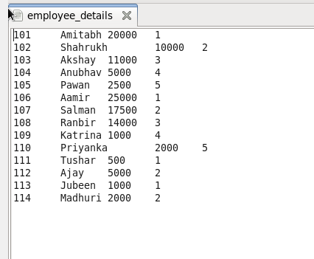

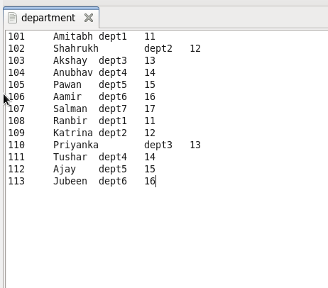

**SELF JOIN:**

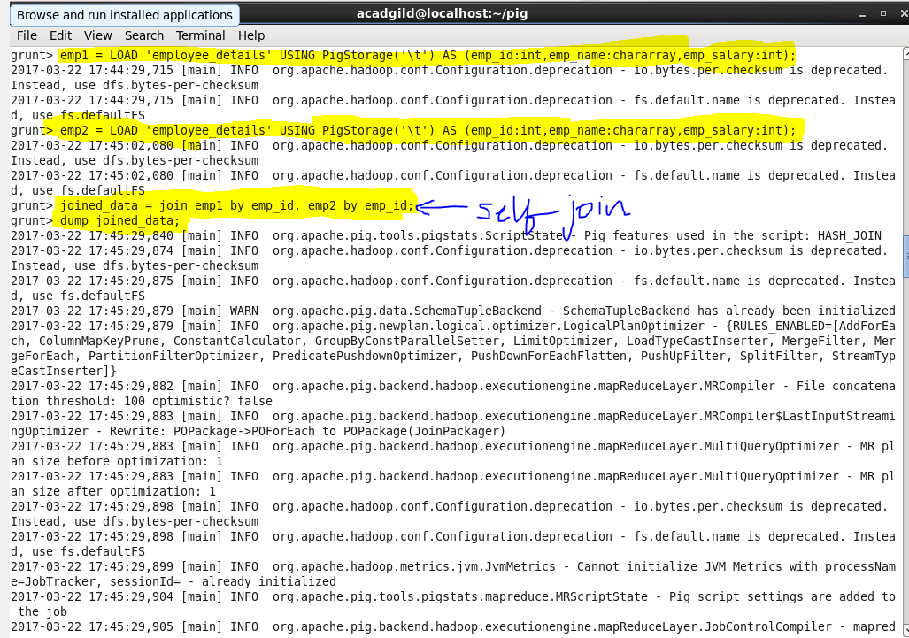

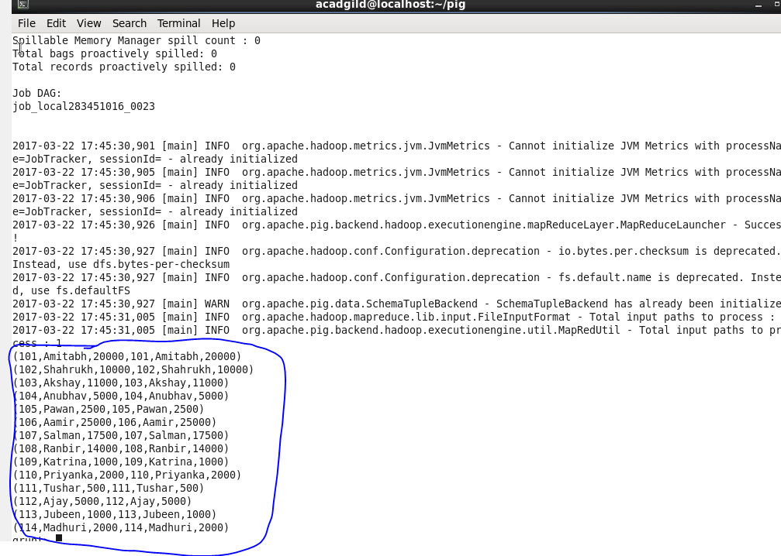

**INNER JOIN:**

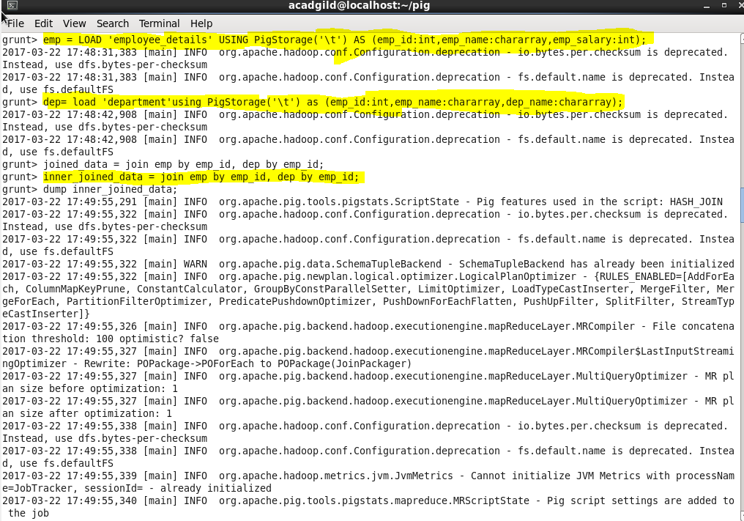

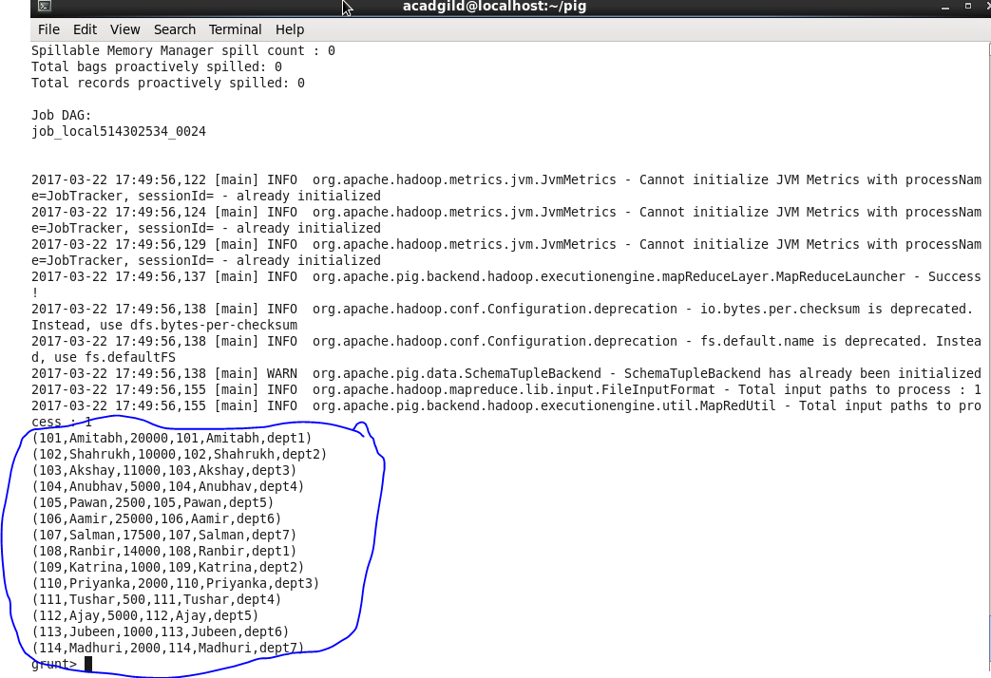

**LEFT OUTER JOIN:** 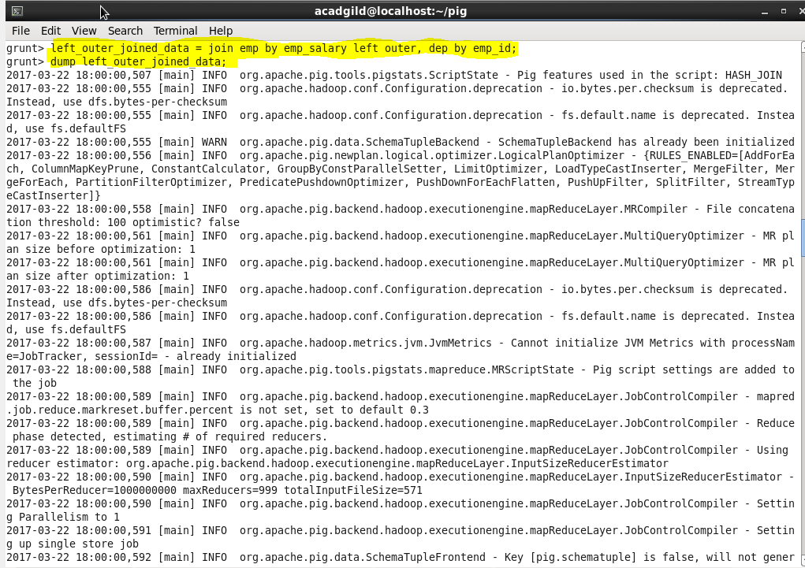

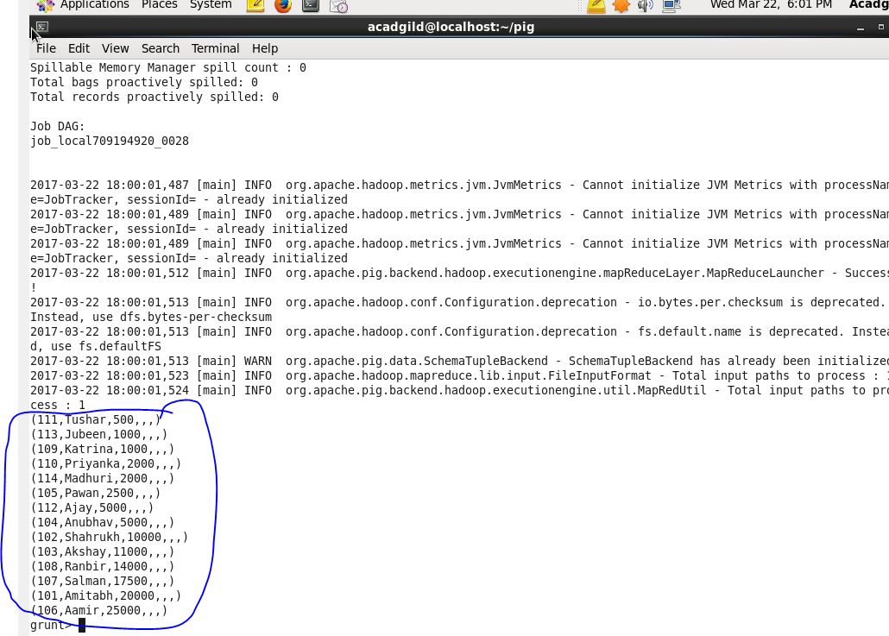

**RIGHT OUTER JOIN:** 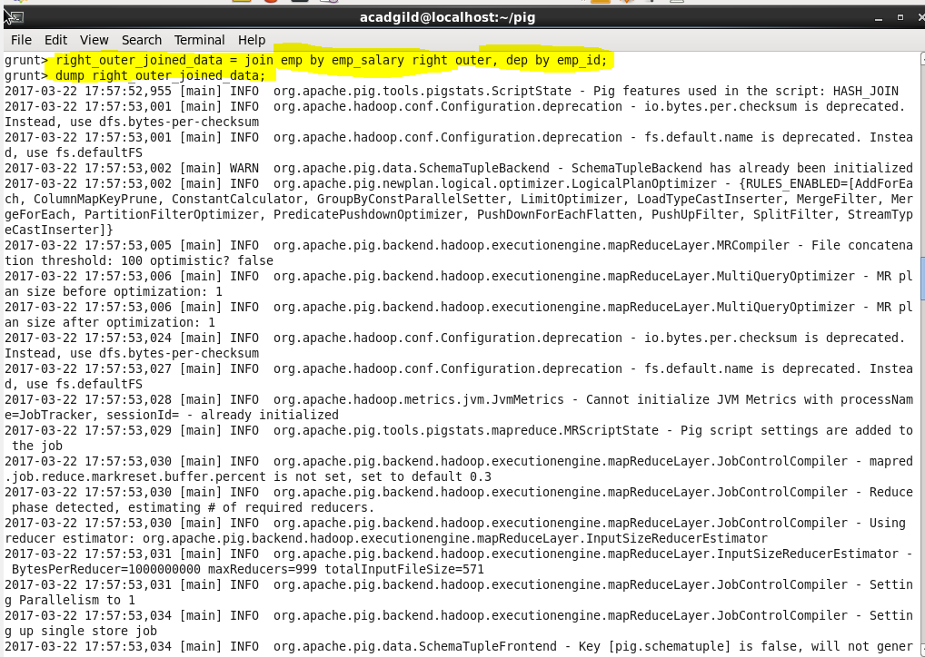

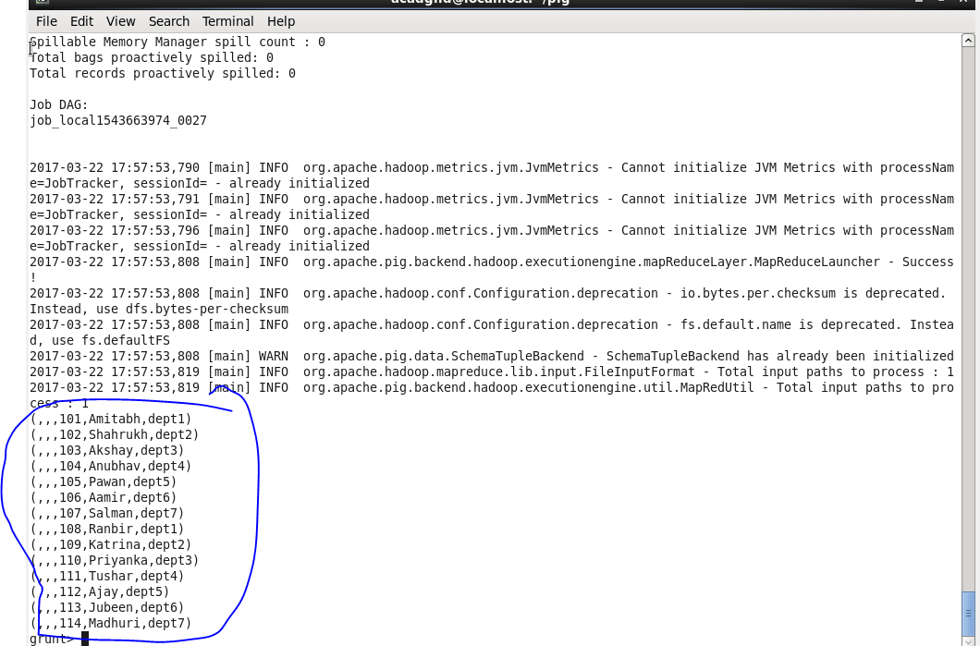

**FULL OUTER JOIN:** 